Date : 27th Jun 2022

Author : Kasshyap Paritala

Advance Excel Assignment 2

1. What does the dollar($) sign do?
   * It Fixes the Relative field/Row/Column, and even if use formula and do drag-down the reference cell would not change along with it.
2. How to Change the Reference from Relative to Absolute (or Mixed)?
   * We can change by the use of the ‘$’ sign within Cell

E.g. – *(In Below Schedule - A stands for Column, and Numeric Stands for the Row)*

|  |  |  |
| --- | --- | --- |
| **Reference Type** | **Cell** | **Description** |
| Relative | **A1** | Allows the row and Column reference to change |
| Mixed | **$A1** | Allows the row reference to change, but not the column reference. |
| Mixed | **A$1** | Allows the column reference to change, but not the row reference. |
| Absolute | **$A$1** | Allows neither the column nor the row reference to change. |

1. Explain the order of operations in excel?
   * Follows an Acronym PEMDAS (Parentheses, Exponents, Multiplication, Division, Addition, Subtraction) followed by Concatenation and Comparison.

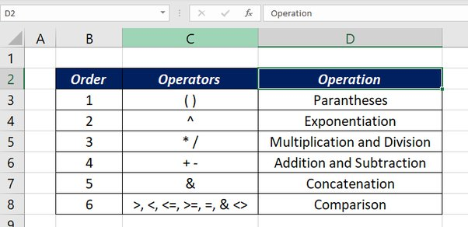

1. What, according to you, are the top 5 functions in excel and write a basic syntax for any of two?
   * SUM
   * SUMIF
     + =SUMIFS(sum_range, criteria_range1, criteria1, …)
   * COUNTIF
   * VLOOKUP
   * COUNTBLANK
     + =COUNTBLANK(range)

1. When would you use the subtotal function?
   * SUBTOTALS help us to get the totals of several columns of data broken down into various categories.
2. What is the syntax of the vlookup function? Explain the terms in it?
   * VLOOKUP Function: Lookups for a value in the first column of a table and returns the value from the same row of the matched value using the index number

=VLOOKUP(lookup_value, table_array, col_index_number)

